Assignment V - Xpath
Name: DEPURU BHARGAVA VENKATA SAI GANESH
REG NO: 212223240025

from selenium import webdriver
from selenium.webdriver.common.by import By
from selenium.webdriver.support.ui import WebDriverWait
from selenium.webdriver.support import expected_conditions as EC
from selenium.webdriver.common.action_chains import ActionChains
import time

driver = webdriver.Chrome()
driver.maximize_window()

wait = WebDriverWait(driver, 15)
driver.get("https://expertdecision.onrender.com/register")
print("TC01 - Registration page opened")

name = wait.until(
EC.visibility_of_element_located(
(By.XPATH, "//input[@placeholder='John Doe']")
)
)

name.send_keys("Bhargava Venkata Sai Ganesh Depuru")

print("TC02 - Full Name entered")

email = wait.until(
EC.visibility_of_element_located(
(By.XPATH, "//input[@placeholder='john@company.com']")
)
)

email.send_keys("saiganeshdepuru06@gmail.com")

print("TC03 - Email entered")

password = wait.until(
EC.visibility_of_element_located(
(By.XPATH, "//input[@type='password'][1]")
)
)

password.send_keys("Saikavya@405")

print("TC04 - Password entered")

confirm_password = wait.until(
EC.visibility_of_element_located(
(By.ID, "confirm_password")
)
)

confirm_password.send_keys("Saikavya@405")

print("TC05 - Confirm Password entered")

employee = wait.until(
EC.element_to_be_clickable(
(By.XPATH, "//label[@for='roleEmployee']")
)
)

employee.click()

print("TC06 - Employee role selected")

continue_button = wait.until(
EC.element_to_be_clickable(
(By.XPATH, "//button[@id='submitBtn']")
)
)

driver.execute_script(
"arguments[0].scrollIntoView({block: 'center'});",
continue_button
)

time.sleep(1)

continue_button.click()

print("Continue to Email Verification clicked")

time.sleep(3)

print("Email verification page opened")

input("\nPress Enter to close browser...")

driver.quit()

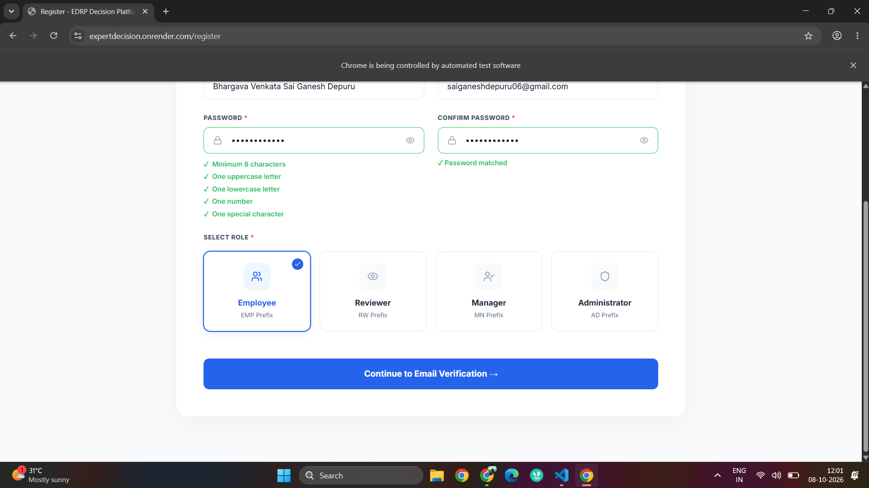
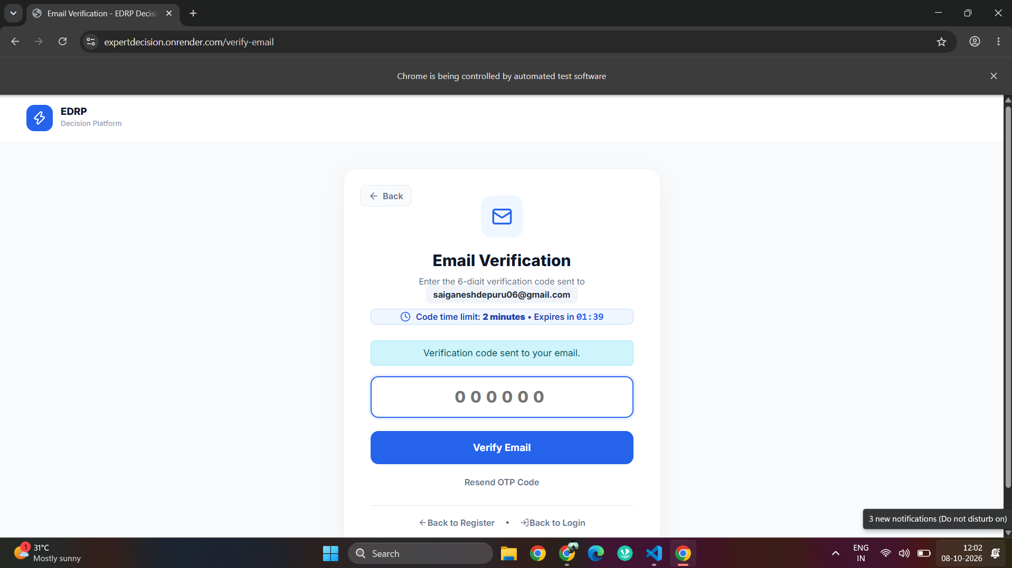
Github Link: https://github.com/saiganesh2006/MANUAL-TEST-CASES-HCL.git

